**ABSTRACT**

In the modern world, it is vital to control appliances in order to minimise human effort, make the best use of available technology, and carry out all tasks in an intelligent and effective manner. Energy must be conserved in every way possible, both outside and inside the immediate environment, because as the population grows, so does energy consumption.

The idea that only one device may operate a variety of home equipment, such as turning on and off loads or appliances, is discussed in this paper. To create a straightforward, low-cost room automation system, multiple appliances are controlled by a single remote control ESP8266.In the proposed scheme, a circuit has been created that satisfies the specifications for operating the room's appliances with a portable remote control that can be used in any location in the room.

Extending this technique to automate a large-scale environment, like offices and factories, would be the next stage. Home Automation provides a universal benchmark for interconnected goods. Standardization makes smart houses possible that has controls for energy, environment, lighting, and appliances management, security, and the capacity to expand connect to more networks.

**INTRODUCTION**

The autonomous management of technological gadgets in our house is known as home automation. These gadgets may be operated from a distance because they are online and connected. You no longer need to manually control your devices, thanks to home automation.

Home automation utilises a network of gadgets linked to the Internet via various protocols, such as Wi-Fi, Bluetooth, etc. The gadgets can be controlled remotely via electronic interfaces using either voice assistants like Alexa or Google Assistant or apps as controllers.

Home automation works on three levels:

Monitoring: Users can remotely check in on their devices through an app to perform monitoring. An individual might be able to see their live feed from a smart security camera, for instance.

Control: Control refers to the user's ability to operate these gadgets remotely, such as by moving a security camera to take in more of a living area.

Automation: Last but not least, automation entails programming gadgets to activate one another, such as having a smart siren sound whenever an activated security camera senses movement.

The term "Internet of Things" in current technological age refers to peculiarly identifiable objects and their digital representation in cyberspace. The Internet of Things (IoT) is a pure way of information processing and accumulation that includes sensor equipment, smart technology, nanotechnology, and other modern technical developments.

IoT offers more adaptable and affordable solutions for issues that arise in daily living, which eventually improves the user's life . Even though numerous prior researchers proposed a variety of home automation systems utilising various sensor combinations, we can infer that there are some motivations for the design of an effective home automation system from the detailed descriptions of those prior studies.

**LITERATURE REVIEW**

Over time, a variety of Smart houses with unique technology have emerged. Numerous solutions based on Arduino and Bluetooth technology have been presented [5], [6]. However, the communication ranges were only up to 50 metres. Additionally, it had a serious problem with a constrained interface for household appliances and sensors. Bluetooth technology was employed for local communication in a networked monitoring system [7] for home automation. utilising RTP (Real-time Transport Protocol) and a web-based GUI to interface with and do remote monitoring via the internet (Graphical User Interface). The suggested approach worked with different types of home automation.programmes, but with a few tweaks. Standby appliances and high-power loads during peak hours have an impact on consumer energy consumption costs, according to an Energy Management Approach for Smart Homes using Bluetooth Low Energy [8]. The outcomes demonstrated that the strategy was effective for lowering peak load demand and power costs while improving user comfort.

It was suggested to implement smart home automation utilising open source software Visual Basic, light and temperature sensors, and Arduino as the master controller [9]. With the use of a visual basic software, voice instructions might be used to operate household equipment. Using the Matlab GUI, the security system guarded the home against invaders. By including wireless communication and schedulers, the system could be improved.

Another Wi-Fi-based study [10] suggested an automation system for home security and power management. The system was suggested for keeping an eye on the temperature, the lighting, and for motion and smoke detection. Locally, using a LAN, users and system administrators could control system code (Local Area Network) or remotely, that is, over the internet, but in both cases the proper web browser and server I.P. The Arduino-based Smart Home Automation and Security System [11] has an integrated web server with IP connectivity and an Android app for device remote control. LDR and temperature sensor LM35 were built into the Arduino for automatic control of lights and fans. Installation of a dedicated server PC wasn't necessary. The system could connect remotely to the home web server, authenticate users, control and monitor devices, and schedule and automatically govern the home environment.Voice activation is supported for password change options and function switching.

A theoretical model was presented [12] to study the elements affecting users' acceptance of smart houses. The study concentrated on elements including perceived dangers, trust, attentiveness, and enjoyment. The SEM-PLS (Structural Equation Modelling- Partial Least Squares) method was employed in the study to determine the empirical strength of the correlations. The risks involved in smart homes had a detrimental effect on acceptance. To increase technological awareness and to provide the better quality of life needed, citizens and smart gadgets should be taught.

**PROPOSED SYSTEM**

The term "Internet of Things" in current technological age refers to peculiarly identifiable objects and their digital representation in cyberspace. The Internet of Things (IoT) is a pure way of information processing and accumulation that includes sensor equipment, smart technology, nanotechnology, and other modern technical developments.

The Internet of Things (IoT) is a fairly broad field, thus this research can't automate everything in it. But the comfort of humans The first area of interest is home automation. The term "home automation" refers to the coordinated operation of all household equipment, which we may manage using an internet-connected Android smartphone, tablet, or computer. In recent years, home automation has gained a lot of appeal.

People enjoy how convenient it is to use remote access to maintain and modify an appliance's status from anywhere in the world. It will eventually be a necessity for everyone.

**System Description :**

Fig. 1 shows the architecture of Smart home automation system. The system is based on ESP32 having dual-

core, inbuilt Wi-Fi and BLE (Bluetooth Low Energy) support as its main controller. The smart home system consists of an application based on the Android OS.

Wi-Fi is used in the presented smart home system to enable capabilities like remote monitoring and control of appliances and surveillance. To accomplish comfort and convenience, the system includes four different types of ESP32-based sensors. The ESP32's built-in Wi-Fi is used to upload all the captured data to Firebase, enabling the designed app to monitor the home environment.

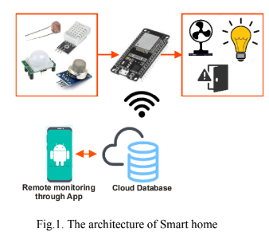

**ESP32:**

The ESP32 is the successor of ESP8266. It combines wireless capabilities Wi-Fi (802.11 b/g/n) and Bluetooth(v4.2). The ESP32 comes with the ESP-WROOM-32 chip. It has a 3.3V voltage regulator that drops the inputvoltage to power the ESP32 chip. And it also comes with a CP2102 chip that allows the ESP32 to plug to thecomputer for programming without the FTDI (Future Technology Devices International) programmer [22].The ESP32 is dual-core, i.e. it has 2 processors. It runs 32-bit programs. The clock frequency can be up t240MHz and 512 kB RAM (Random-access memory). It also has many peripherals like capacitive touch,ADCs, DACs, UART, SPI, and I2C. The board has two onboard buttons ENABLE and the BOOT button. It isan open-source resource and plug-and-play modules that support thousands of compatible boards and sensors.It has everything needed to support the microcontroller.

**Android Application:**

The most popular operating system for smartphones and tablets is Android. The IDE (Integrated Development Environment) for Android development is called Android Studio. The Android app's goals include managing schedules and controlling devices. Developers can easily edit the source code using Android Studio, which is available for free download. Flutter is the foundation of the system app that was created. Lights and fans may be turned on and off using the app.

**Firebase:**

A free Google Cloud database is Firebase. The Firebase Real-time Database uses data synchronisation rather than standard HTTP (Hypertext Transfer Protocol) requests, which means that whenever data changes, any connected device instantly receives the update. ESP32's built-in Wi-Fi is used to enable a connection to Firebase over the internet. Firebase Host ID and Firebase Auth are used to make a connection to the Firebase server.

**Working:**

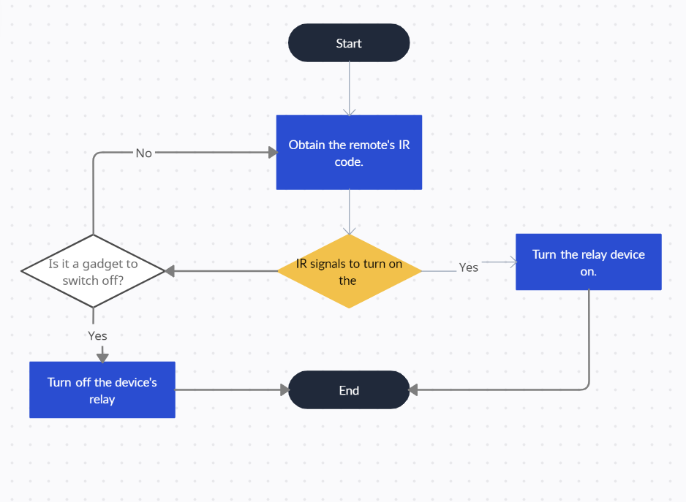

FLOWCHART OF PROPOSED SYSTEM

**RESULT AND CONCLUSION**

A straightforward, low-cost home automation system is created and put into use to raise the level of living in smart homes. Elderly and disabled users of the system will find it easy to utilise. Similar comparisons are made with other systems created utilising various technologies. As can be observed from Fig. 7, the price of the Arduino-based system is 1.8 times less than that of other home automation systems. the price of the parts needed to create an inexpensive home automation system that uses an IR remote. In Table 1, the components are listed along with their details and price.

| **Electronic components** | **Quantity** | **Cost(in Rs.)** |
| --- | --- | --- |
| ESP 32 | 1 | 310 |
| OLED | 1 | 320 |
| Relay | 1 | 72 |
| LEDs | 5 | 25 |
| Cables | 1 | 10 |
| Bred Board | 1 | 100 |
| **Total:** |  | 837 |

Table 1. Cost of components used

**FUTURE SCOPE**

Given the situation, we can create a cross-platform system that can be used on many operating systems, including iOS and Windows. By automating all other home appliances, the restriction of being able to control only a few gadgets can be lifted. The prototype could have sensors for automatic control of the home's appliances, such as an LDR that can detect daylight and turn on the lights accordingly, a PIR that can detect motion and be used to sound an alarm for security, or a DHT11 sensor that detects the ambient temperature and humidity of the air and turns on the fans and air conditioner appropriately. By extending the project's scope beyond just the house and small offices, it can cover a wide range of topics.

**References:**

[1] Bhati, Abhishek & Hansen, Michael & Chan, Ching, 2017. Energy conservation through smart homes in a smart city: A lesson for

Singapore households, Energy Policy, 104 p. 230.

[2] Aditya Chunekar, Sapekshya Varshney, Shantanu Dixit, 2016. Residential Electricity Consumption in India, Prayas (Energy

Group).

[3] Richard Harper, 2003. Inside the Smart Home, Springer.

[4] Smart home energy saving, Research Report A1801, American Council for an Energy-Efficient Economy (ACEEE), April 2018.

[5] R. Piyare and M. Tazil, 2011. Bluetooth based home automation system using cell phone, IEEE 15th International Symposium on

Consumer Electronics (ISCE), p. 192.

[6] M. Asadullah and K. Ullah, 2017. Smart home automation system using Bluetooth technology, 2017 International Conference on

Innovations in Electrical Engineering and Computational Technologies (ICIEECT), p. 1.

[7] G. Song, Z. Wei, W. Zhang and A. Song, 2007. Design of a Networked Monitoring System for Home Automation, IEEE

Transactions on Consumer Electronics 53, p. 933.

[8] M. Collotta and G. Pau, 2015. A Novel Energy Management Approach for Smart HomesUsing Bluetooth Low Energy, IEEE

Journal on Selected Areas in Communications 33, p. 2988.

[9] Subhankar Chattoraj, 2015. Smart Home Automation based on different sensors and Arduino as the master controller, International

Journal of Scientific and Research Publications 5.

[10] Ahmed El Shafee and Karim Alaa Hamed, 2012. Design and Implementation of a Wi-Fi based Home Automation System, World

Academy of Science, Engineering and Technology International Journal of Computer and Information Engineering 6.

[11] A, J.Chandramohan & Ramalingam, Nagarajan & Satheeshkumar, K. & Ajithkumar, N. & Gopinath, P.A. & Ranjithkumar, S,

2017. Intelligent Smart Home Automation and Security System Using Arduino and Wi-fi, International Journal of Engineering And

Computer Science, 10.

[12] Shuhaiber, Ahmed & Mashal, Ibrahim, 2019. Understanding user’s acceptance of smart homes, Technology in Society.